**Comprehensive Analysis and Dietary Strategies with Tableau: A College Food Choices**

**Analysis: Final Report**

|  |  |
| --- | --- |
| Date | 25 June 2025 |
| Team ID | LTVIP2025TMID48149 |
| Project Name | Comprehensive Analysis and Dietary Strategies with Tableau: A College Food Choices |

**1. INTRODUCTION**

**1.1 Project Overview**

"Comprehensive Analysis and Dietary Strategies with Tableau" is a data visualization project that aims to analyze the food choices and dietary habits of college students. By leveraging Tableau, this project visualizes trends in student nutrition and proposes data-driven solutions to enhance student health and academic outcomes.

**1.2 Purpose**

* The purpose is to empower educational institutions with actionable insights into student nutrition, enabling effective decision-making to foster healthier eating habits and overall well-being.

**2. IDEATION PHASE**

**2.1 Problem Statement**

Many college students adopt poor dietary habits due to academic stress, lack of awareness, or convenience, which can impact their health and performance. There is a need to analyse and address these trends proactively.

**2.2 Empathy Map Canvas**

* *Think & Feel:* “I don’t have time to plan meals”; “Healthy food is expensive.”
* *See:* Junk food advertisements; Unhealthy cafeteria options.
* *Say & Do:* Skips meals; Eats packaged snacks often.
* *Pain:* Poor energy, frequent illness, lack of concentration.
* *Gain:* Improved health, better focus, academic improvement.

**2.3 Brainstorming**

* Use Tableau to visualize patterns in student diet.
* Predict deficiencies or risky patterns.
* Recommend personalized meal plans and awareness campaigns.

**3. REQUIREMENT ANALYSIS**

**3.1 Customer Journey Map**

From data collection through surveys or cafeteria records → Data preprocessing → Visualization on Tableau → Analysis and Recommendations.

**3.2 Solution Requirement**

* Dataset of student meals, nutritional value, and health outcomes.
* Tableau for visualization.
* Filtering and forecasting tools.

**3.3 Data Flow Diagram**

| Data Collection | -----> | Data Preprocessing | -----> | Tableau Dashboard | | (Surveys, Logs) | | (Cleaning & Merge) | | (Visualization) |

**3.4 Technology Stack**

* *Tableau Public*
* *Excel/CSV Datasets*
* *Google Forms/Surveys*
* *Python (optional for preprocessing)*

**4. PROJECT DESIGN**

**4.1 Problem Solution Fit**

The project identifies gaps in student nutrition and proposes corrective strategies based on data.

**4.2 Proposed Solution**

* A set of interactive dashboards using Tableau, highlighting patterns in food consumption, deficiencies, and suggesting improvements.

**4.3 Solution Architecture**

* Frontend: Tableau Dashboards
* Backend: CSV/Excel datasets from surveys or food logs

**5. PROJECT PLANNING & SCHEDULING**

**5.1 Project Planning**

* *Week 1-2:* Requirement gathering and dataset sourcing
* *Week 3-4:* Data preprocessing and analysis
* *Week 5-6:* Tableau dashboard creation
* *Week 7:* Testing and feedback
* *Week 8:* Documentation and final presentation

**6. FUNCTIONAL AND PERFORMANCE TESTING**

**6.1 Performance Testing**

* Dashboards were tested for responsiveness and interactivity.
* Datasets were validated for accuracy.
* Stakeholder feedback ensured usability and clarity.

### **7. *RESULTS***

#### **7.1 Output Screenshots**

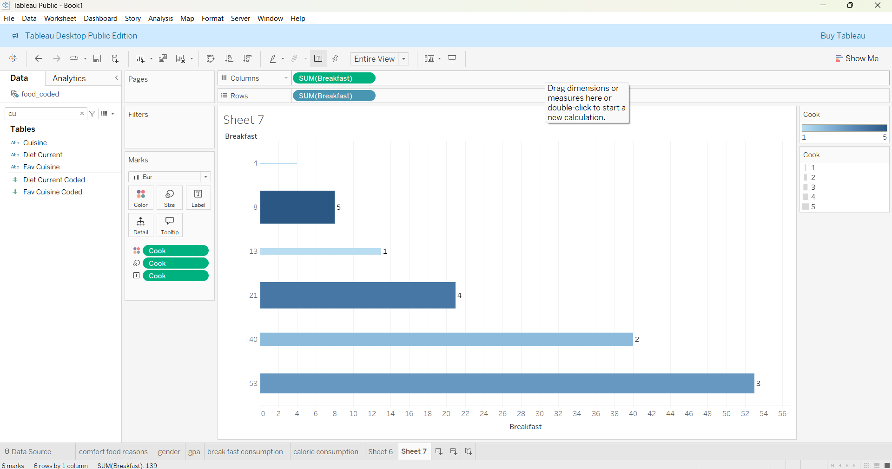

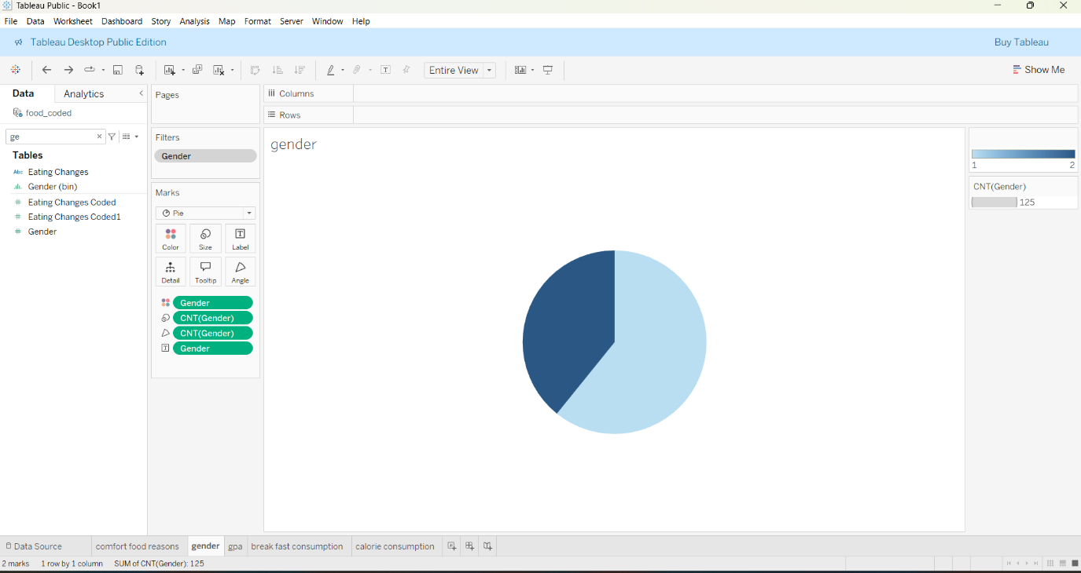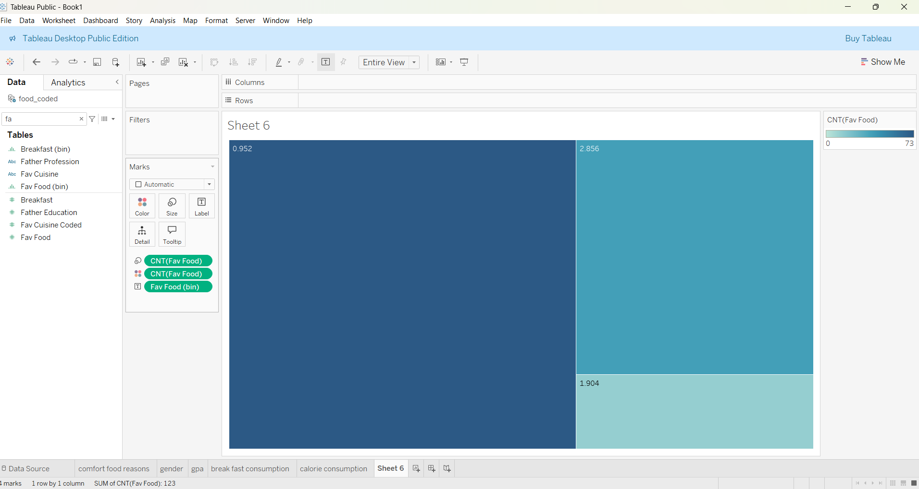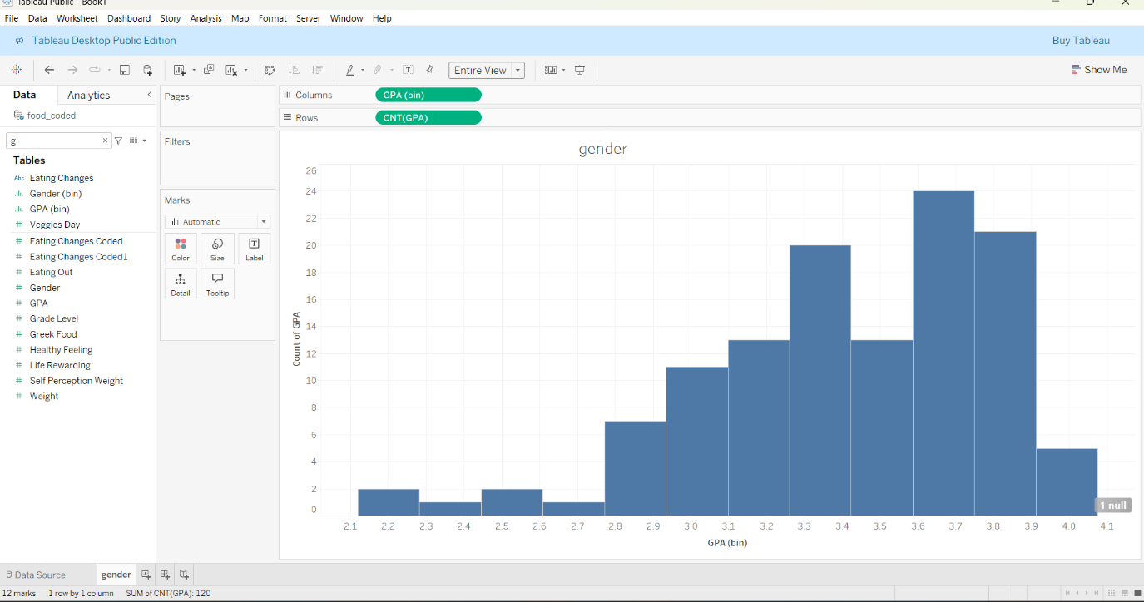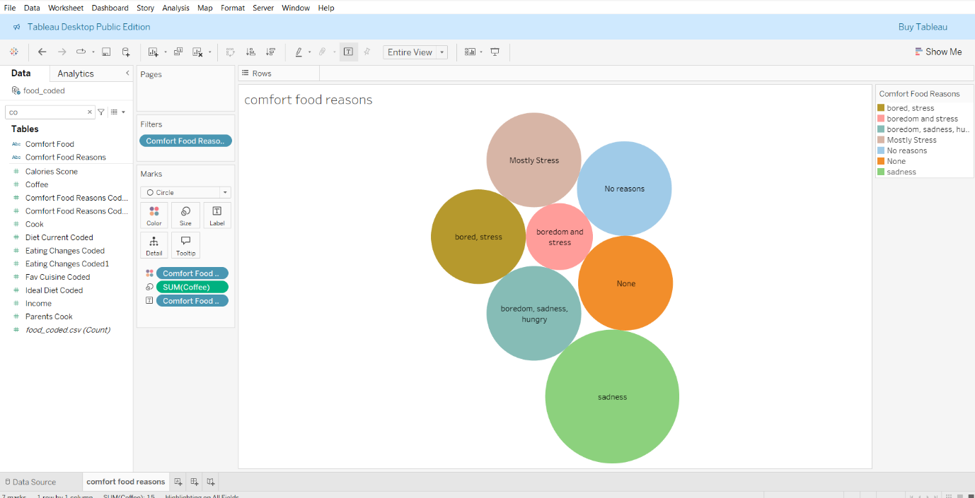

### **8. *ADVANTAGES & DISADVANTAGES***

*Advantages:*

* Real-time insights
* Easy-to-understand visualizations
* Predictive capabilities

*Disadvantages:*

* Depends on data accuracy
* Manual data entry may be required
* Requires Tableau proficiency

**Conclusion**  
This project successfully demonstrates the power of data visualization to improve student health through informed dietary choices. With real-time analytics, institutions can make proactive decisions to foster a healthier environment.

### **9. *CONCLUSION***

This project successfully demonstrates the power of data visualization to improve student health through informed dietary choices. With real-time analytics, institutions can make proactive decisions to foster a healthier environment.

### **10. *FUTURE SCOPE***

* Integration with wearable fitness devices
* Automated data entry via food scanning
* Expansion to include mental health correlations

### **11. *APPENDIX***

* *GitHub Link:* [*https://github.com/Geethika-dasi*](https://github.com/Geethika-dasi)

Report Prepared by:

Dasi Geethika